8 Key Application Performance Metrics & How to Measure Them

MATT WATSONJULY 3, 2017[INSIGHTS FOR DEV MANAGERS](https://stackify.com/team/), [POPULAR](https://stackify.com/popular/)[LEAVE A COMMENT](https://stackify.com/application-performance-metrics/#respond)

If you are trying to figure out how to measure the performance of your application, you are in the correct place. We spend a lot of time at Stackify thinking about application performance, especially about how to monitor and improve it. In this article, we cover some of our most important application performance metrics you should be tracking.

Key Application Performance Metrics

1. User Satisfaction / Apdex Scores

The application performance index, or [Apdex](https://www.apdex.org/" \t "_blank) score, has become an industry standard for tracking the relative performance of an application.

It works by specifying a goal for how long a specific web request or transaction should take.

Those transactions are then bucketed into satisfied (fast), tolerating (sluggish), too slow, and failed requests. A simple math formula is then applied to provide a score from 0 to 1.

Developers Need Smart Application Metrics, Not Server Monitoring

[Retrace](https://stackify.com/retrace/) automatically tracks satisfaction scores for every one of your applications and web requests. We convert the number to a 0-100 instead of 0-1 representation to make it easier to understand.

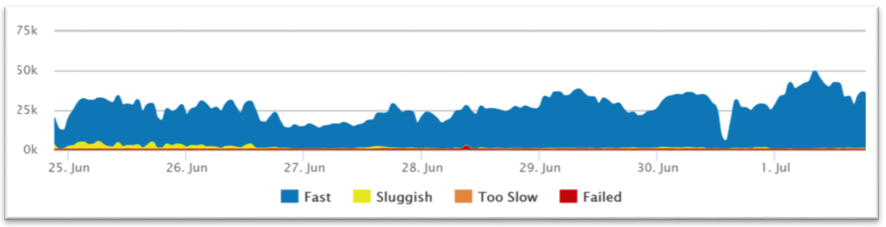

RETRACE SATISFACTION CHART

2. Average Response Time

Let me start by saying that **averages suck**. I highly recommend using the aforementioned user satisfaction Apdex scores as a preferred way to track overall performance. That said, averages are still a useful application performance [metric](https://stackify.com/15-metrics-for-devops-success/).

Application Performance Metrics Averages

3. Error Rates

The last thing you want your users to see are errors. [Monitoring error rates](http://stackify.com/error-monitoring/) is a critical application performance metric.

There are potentially 3 different ways to track application errors:

* HTTP Error % – Number of web requests that ended in an error
* Logged Exceptions – Number of unhandled and logged errors from your application
* Thrown Exceptions – Number of [all exceptions](http://stackify.com/csharp-catch-all-exceptions/) that have been thrown

It is common to see thousands of exceptions being thrown and ignored within an application. Hidden application exceptions can cause a lot of performance problems.

4. Count of Application Instances

If your application scales up and down in the cloud, it is important to know how many server/application instances you have running. Auto-scaling can help ensure your application scales to meet demand and saves you money during off-peak times. This also creates some unique monitoring challenges.

For example, if your application automatically scales up based on CPU usage, you may never see your CPU get high. You would instead see the number of server instances get high. (Not to mention your hosting bill going way up!)

5. Request Rate

Understanding how much traffic your application receives will impact the success of your application. Potentially all other application performance metrics are affected by increases or decreases in traffic.

Request rates can be useful to correlate to other application performance metrics to understand the dynamics of how your application scales.

Monitoring the request rate can also be good to watch for spikes or even inactivity. If you have a busy API that suddenly gets no traffic at all, that could be a really bad thing to watch out for.

A similar but slightly different metric to track is the number of concurrent users. This is another interesting metric to track to see how it correlates.

6. Application & Server CPU

If the CPU usage on your server is extremely high, you can guarantee you will have application performance problems. Monitoring the CPU usage of your server and applications is a basic and critical metric.

Virtually all server and [application monitoring](http://stackify.com/application-monitoring/) tools can track your CPU usage and provide monitoring alerts. It is important to track them per server but also as an aggregate across all the individually deployed instances of your application.

7. Application Availability

Monitoring and measuring if your application is online and available is a key metric you should be tracking. Most companies use this as a way to measure uptime for service level agreements (SLA).

If you have a web application, the easiest way to monitor application availability is via a simple scheduled HTTP check.

Retrace can run these types of HTTP “ping” checks every minute for you. It can monitor response times, status codes, and even look for specific content on the page.

8. Garbage Collection

If your application is written in .NET, C#, or other programming languages that use [garbage collection](http://stackify.com/what-is-java-garbage-collection/), you are probably aware of the performance problems that can arise from it.

When garbage collection occurs, it can cause your process to suspend and can use a lot of CPU.

Garbage collection metrics may not be one of the first things you think about key application performance metrics. It can be a hidden performance problem that is always a good idea to keep an eye on.

For .NET, you can monitor this via the Performance Counter of “% GC Time”. Java has similar capabilities via JMX metrics. Retrace can monitor these via its [application metrics](http://stackify.com/application-metrics/) capabilities.

Summary

Application performance measurement is necessary for all types of applications. Depending on your type of application, there could be many other monitoring needs.

[Retrace](https://stackify.com/retrace/) can help you monitor a broad range of web application performance metrics. Retrace collects critical metrics about your applications, servers, code level performance, application errors, logs, and more. These can be used for measuring and monitoring the performance of your application.